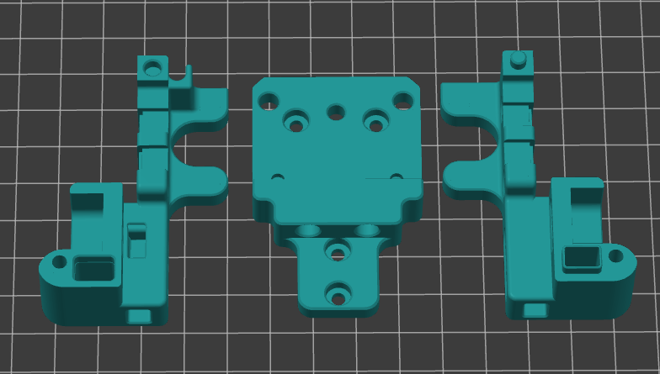

Parts in the image are printed with PA12-CF15,

But you could print it with ABS or ASA. PLA and PETG not supported or tested.

**PA12-CF15 ABS or ASA**

Layer height: 0.2mm Layer height: 0.2mm

Perimeters: 4 Perimeters: 4

Solid layers Top: 5 Solid layers Top: 5

Solid layers Bottom: 5 Solid layers Bottom: 5

Infill: 40% Infill: 40%

Infill pattern: Grid Infill pattern: Grid  
Nozzle Temp.: 280C Nozzle Temp.: 255C  
Bed Temp.: 100C Bed Temp.: 90C  
Chamber Temp.: 48-50C Chamber Temp.: 40-45C  
Outer wall: 40 mm/s Outer wall: 45 mm/s

Inner wall 60 mm/s Inner wall 120 mm/s

Infill 80 mm/s Infill 140 mm/s

**No support needed!!! No support needed!!!**